SecurityConfig.java
package com.cognizant.spring_learn.security;

import org.springframework.context.annotation.Bean;
import org.springframework.context.annotation.Configuration;
import org.springframework.security.config.Customizer;
import org.springframework.security.config.annotation.web.builders.HttpSecurity;
import org.springframework.security.crypto.bcrypt.BCryptPasswordEncoder;
import org.springframework.security.crypto.password.PasswordEncoder;
import org.springframework.security.provisioning.InMemoryUserDetailsManager;
import org.springframework.security.core.userdetails.User;
import org.springframework.security.web.SecurityFilterChain;

@Configuration
public class SecurityConfig {

@Bean
public InMemoryUserDetailsManager userDetailsService() {

return new InMemoryUserDetailsManager(
User.withUsername("user")
.password(passwordEncoder().encode("pwd"))
.roles("USER")
.build(),

User.withUsername("admin")
.password(passwordEncoder().encode("pwd"))
.roles("ADMIN")
.build()
);
}

@Bean
public PasswordEncoder passwordEncoder() {
return new BCryptPasswordEncoder();
}

@Bean
public SecurityFilterChain filterChain(HttpSecurity http)
throws Exception {

http
.csrf(csrf -> csrf.disable())
.httpBasic(Customizer.withDefaults())
.authorizeHttpRequests(auth -> auth
.requestMatchers("/countries").hasRole("USER")
.requestMatchers("/authenticate")
.hasAnyRole("USER","ADMIN")
.anyRequest().authenticated());

return http.build();
}
}
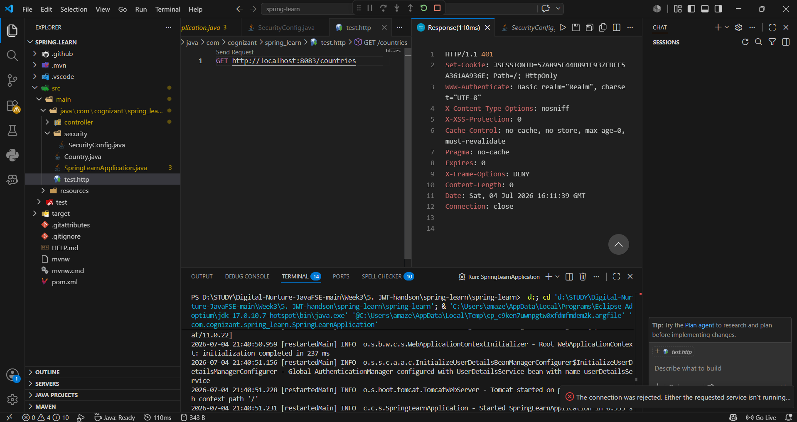
Basic Auth
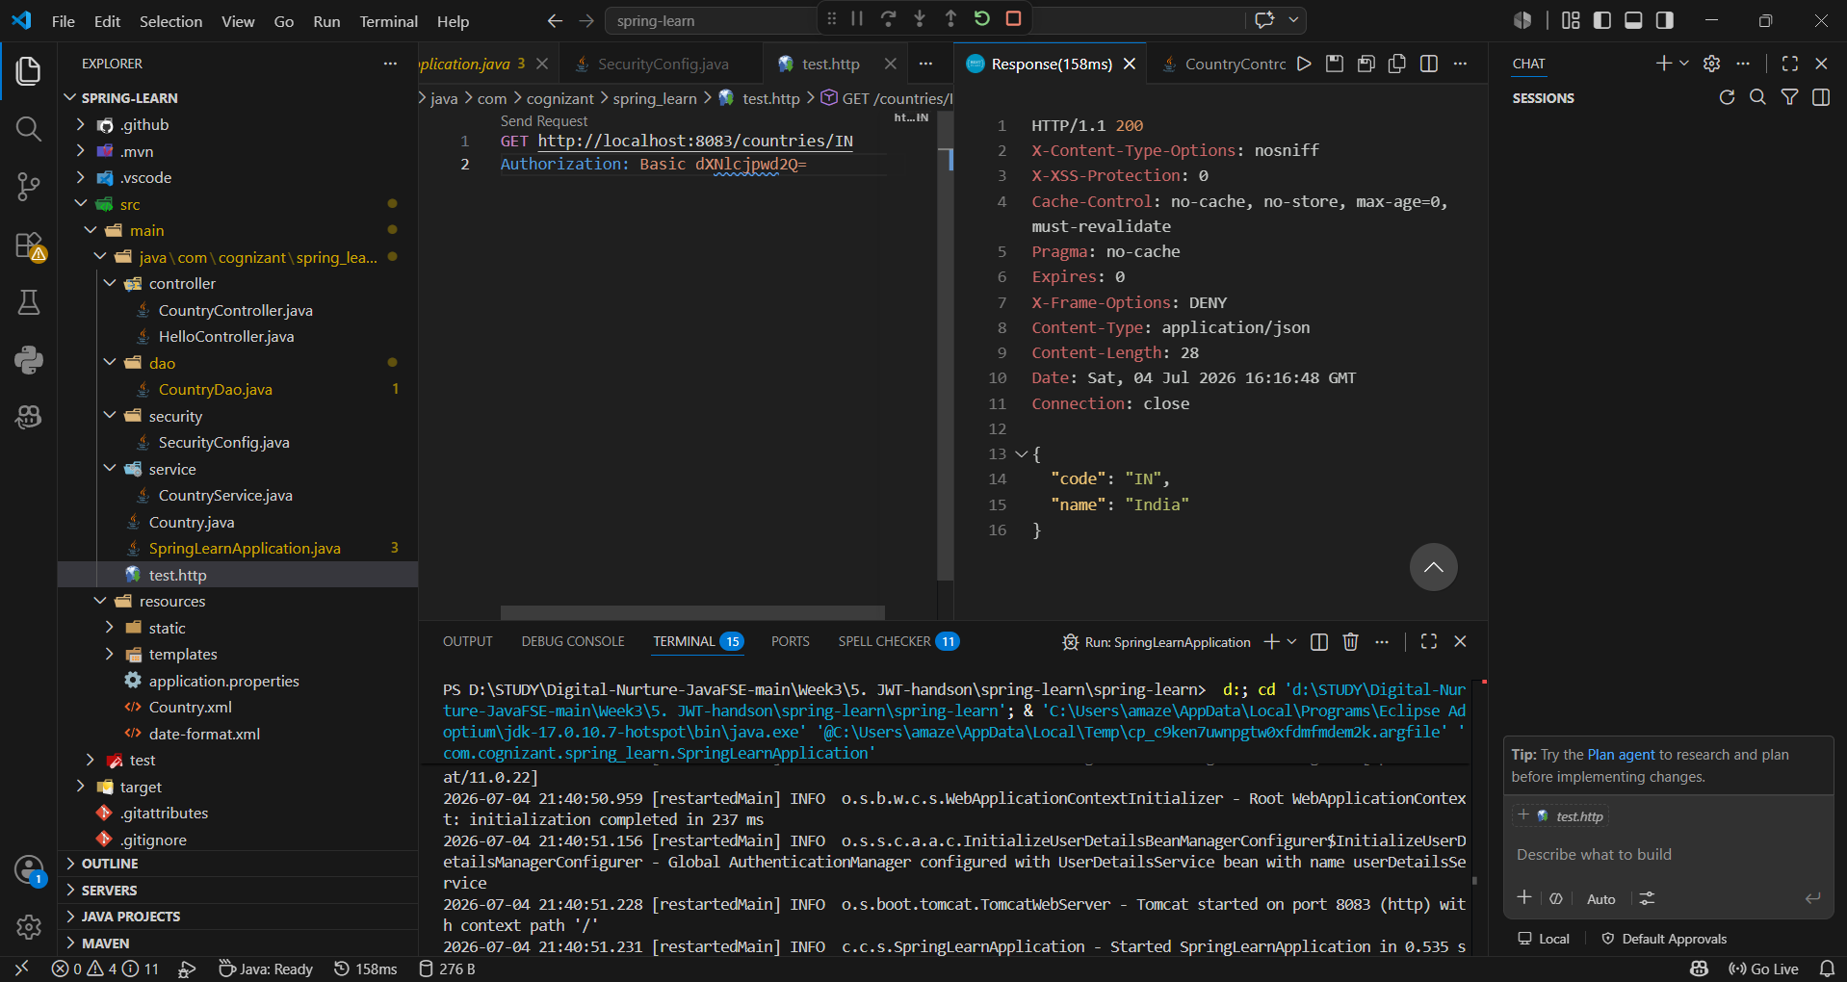

CountryDao.java
package com.cognizant.spring_learn.dao;

import java.util.ArrayList;
import java.util.List;

import org.springframework.context.ApplicationContext;
import org.springframework.context.support.ClassPathXmlApplicationContext;
import org.springframework.stereotype.Repository;

import com.cognizant.spring_learn.Country;

@Repository
public class CountryDao {

private static List<Country> countryList = new ArrayList<>();

public CountryDao() {

ApplicationContext context =
new ClassPathXmlApplicationContext("country.xml");

countryList.add(context.getBean("country", Country.class));

Country us = new Country();
us.setCode("US");
us.setName("United States");

Country de = new Country();
de.setCode("DE");
de.setName("Germany");

Country jp = new Country();
jp.setCode("JP");
jp.setName("Japan");

countryList.add(us);
countryList.add(de);
countryList.add(jp);
}

public List<Country> getAllCountries() {
return countryList;
}

public Country getCountry(String code) {

return countryList.stream()
.filter(c -> c.getCode().equalsIgnoreCase(code))
.findFirst()
.orElse(null);
}
}
CountryService.java
package com.cognizant.spring_learn.service;

import java.util.List;

import org.springframework.beans.factory.annotation.Autowired;
import org.springframework.stereotype.Service;

import com.cognizant.spring_learn.Country;
import com.cognizant.spring_learn.dao.CountryDao;

@Service
public class CountryService {

@Autowired
private CountryDao dao;

public List<Country> getAllCountries() {
return dao.getAllCountries();
}

public Country getCountry(String code) {
return dao.getCountry(code);
}
}
CountryController.java
package com.cognizant.spring_learn.controller;

import java.util.List;

import org.springframework.beans.factory.annotation.Autowired;
import org.springframework.web.bind.annotation.*;

import com.cognizant.spring_learn.Country;
import com.cognizant.spring_learn.service.CountryService;

@RestController
@RequestMapping("/countries")
public class CountryController {

@Autowired
private CountryService service;

@GetMapping
public List<Country> getAllCountries() {
return service.getAllCountries();
}

@GetMapping("/{code}")
public Country getCountry(@PathVariable String code) {
return service.getCountry(code);
}
}

All Countries
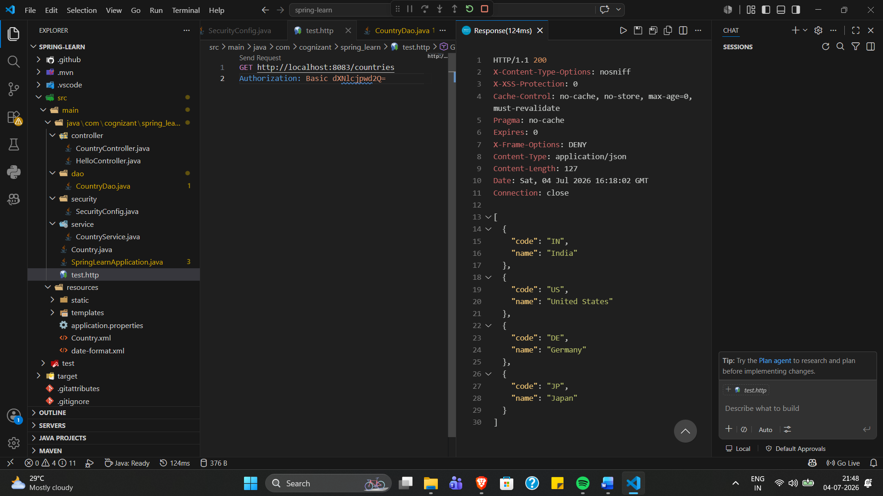
One Country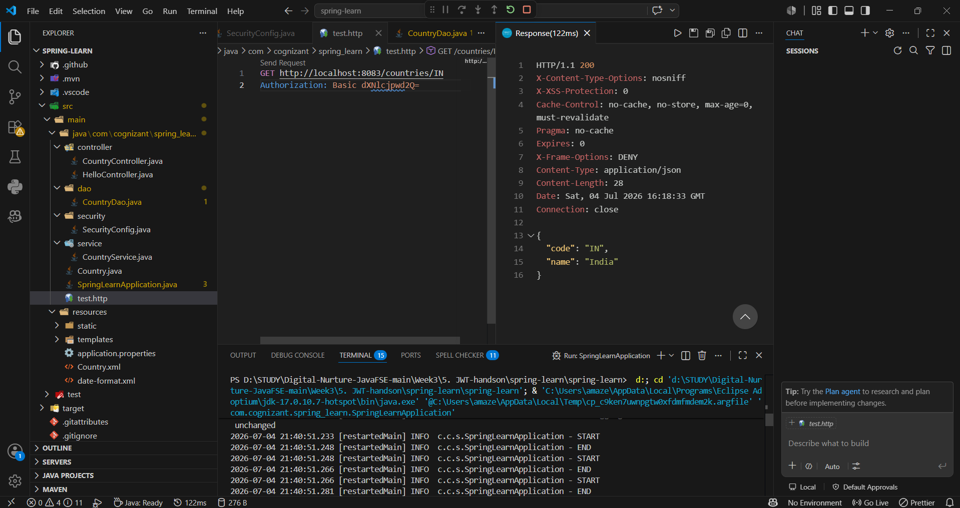

AuthenticationController.java
package com.cognizant.spring_learn.controller;

import java.util.Base64;
import java.util.Date;
import java.util.HashMap;
import java.util.Map;

import org.springframework.web.bind.annotation.GetMapping;
import org.springframework.web.bind.annotation.RequestHeader;
import org.springframework.web.bind.annotation.RestController;

import io.jsonwebtoken.Jwts;
import io.jsonwebtoken.SignatureAlgorithm;

@RestController
public class AuthenticationController {

@GetMapping("/authenticate")
public Map<String, String> authenticate(
@RequestHeader("Authorization") String authHeader) {

String user = getUser(authHeader);

String token = generateJwt(user);

Map<String, String> map = new HashMap<>();
map.put("token", token);

return map;
}

private String getUser(String authHeader) {

String encoded = authHeader.substring(6);

byte[] decoded = Base64.getDecoder().decode(encoded);

String credentials = new String(decoded);

return credentials.substring(0, credentials.indexOf(":"));
}

private String generateJwt(String user) {

return Jwts.builder()
.setSubject(user)
.setIssuedAt(new Date())
.setExpiration(new Date(System.currentTimeMillis() + 1200000))
.signWith(SignatureAlgorithm.HS256, "secretkey")
.compact();
}
}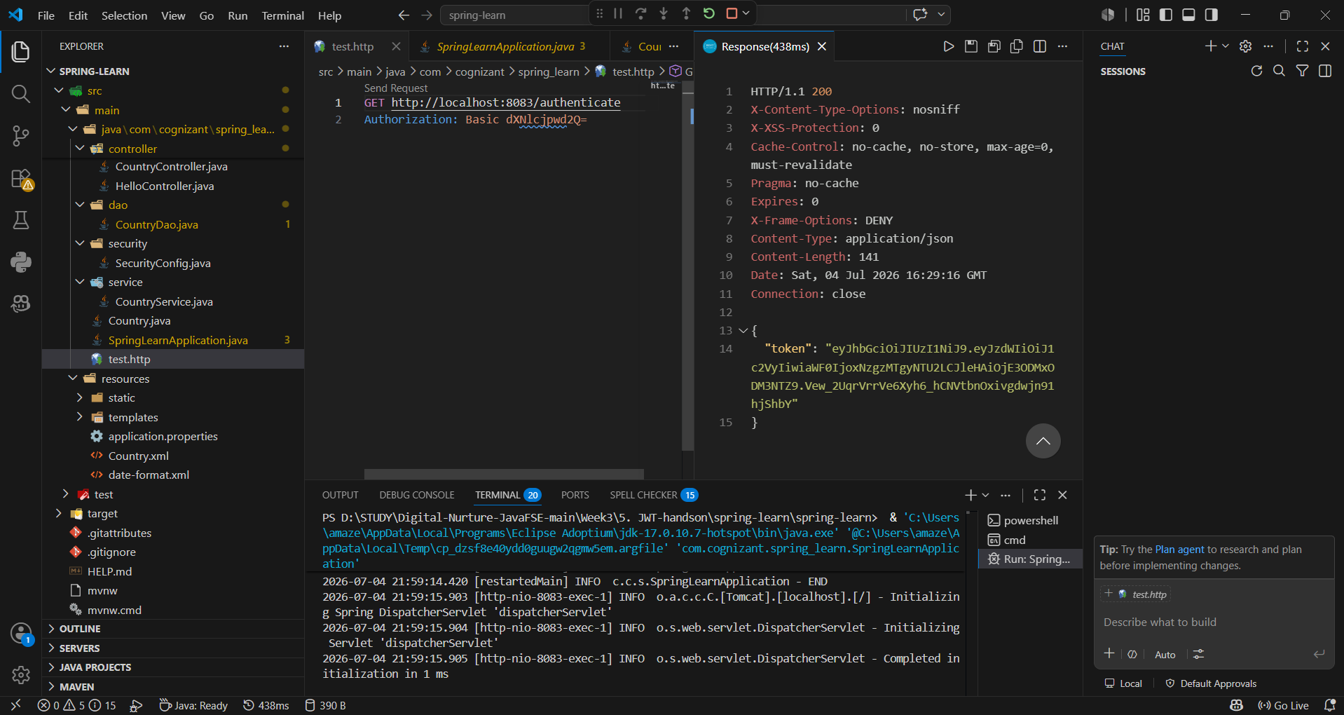
JwtAuthenticationFilter.java
package com.cognizant.spring_learn.security;

import java.io.IOException;
import java.nio.charset.StandardCharsets;

import javax.crypto.SecretKey;

import io.jsonwebtoken.Claims;
import io.jsonwebtoken.Jwts;
import io.jsonwebtoken.security.Keys;

import jakarta.servlet.FilterChain;
import jakarta.servlet.ServletException;
import jakarta.servlet.http.HttpServletRequest;
import jakarta.servlet.http.HttpServletResponse;

import org.springframework.security.authentication.UsernamePasswordAuthenticationToken;
import org.springframework.security.core.context.SecurityContextHolder;
import org.springframework.web.filter.OncePerRequestFilter;

public class JwtAuthorizationFilter extends OncePerRequestFilter {

private final SecretKey key =
Keys.hmacShaKeyFor(
"ThisIsASecretKeyForJwtAuthentication12345"
.getBytes(StandardCharsets.UTF_8));

@Override
protected void doFilterInternal(HttpServletRequest request,
HttpServletResponse response,
FilterChain filterChain)
throws ServletException, IOException {

String header = request.getHeader("Authorization");

if (header == null || !header.startsWith("Bearer ")) {
filterChain.doFilter(request, response);
return;
}

try {

String token = header.substring(7);

Claims claims = Jwts.parser()
.verifyWith(key)
.build()
.parseSignedClaims(token)
.getPayload();

String user = claims.getSubject();

UsernamePasswordAuthenticationToken authentication =
new UsernamePasswordAuthenticationToken(
user,
null,
java.util.Collections.emptyList());

SecurityContextHolder.getContext()
.setAuthentication(authentication);

} catch (Exception ex) {

SecurityContextHolder.clearContext();
}

filterChain.doFilter(request, response);
}
}
SecurityConfig.java
package com.cognizant.spring_learn.security;

import org.springframework.context.annotation.Bean;
import org.springframework.context.annotation.Configuration;
import org.springframework.security.config.Customizer;
import org.springframework.security.config.annotation.web.builders.HttpSecurity;
import org.springframework.security.crypto.bcrypt.BCryptPasswordEncoder;
import org.springframework.security.crypto.password.PasswordEncoder;
import org.springframework.security.provisioning.InMemoryUserDetailsManager;
import org.springframework.security.core.userdetails.User;
import org.springframework.security.web.SecurityFilterChain;
import org.springframework.security.web.authentication.www.BasicAuthenticationFilter;

@Configuration
public class SecurityConfig {

@Bean
public InMemoryUserDetailsManager userDetailsService() {

return new InMemoryUserDetailsManager(
User.withUsername("user")
.password(passwordEncoder().encode("pwd"))
.roles("USER")
.build(),

User.withUsername("admin")
.password(passwordEncoder().encode("pwd"))
.roles("ADMIN")
.build()
);
}

@Bean
public PasswordEncoder passwordEncoder() {
return new BCryptPasswordEncoder();
}

@Bean
public SecurityFilterChain filterChain(HttpSecurity http)
throws Exception {

http
.csrf(csrf -> csrf.disable())

.httpBasic(Customizer.withDefaults())

.authorizeHttpRequests(auth -> auth

.requestMatchers("/authenticate")
.hasAnyRole("USER", "ADMIN")

.anyRequest()
.authenticated())

.addFilterBefore(
new JwtAuthorizationFilter(),
BasicAuthenticationFilter.class);

return http.build();
}
}

Generated Token
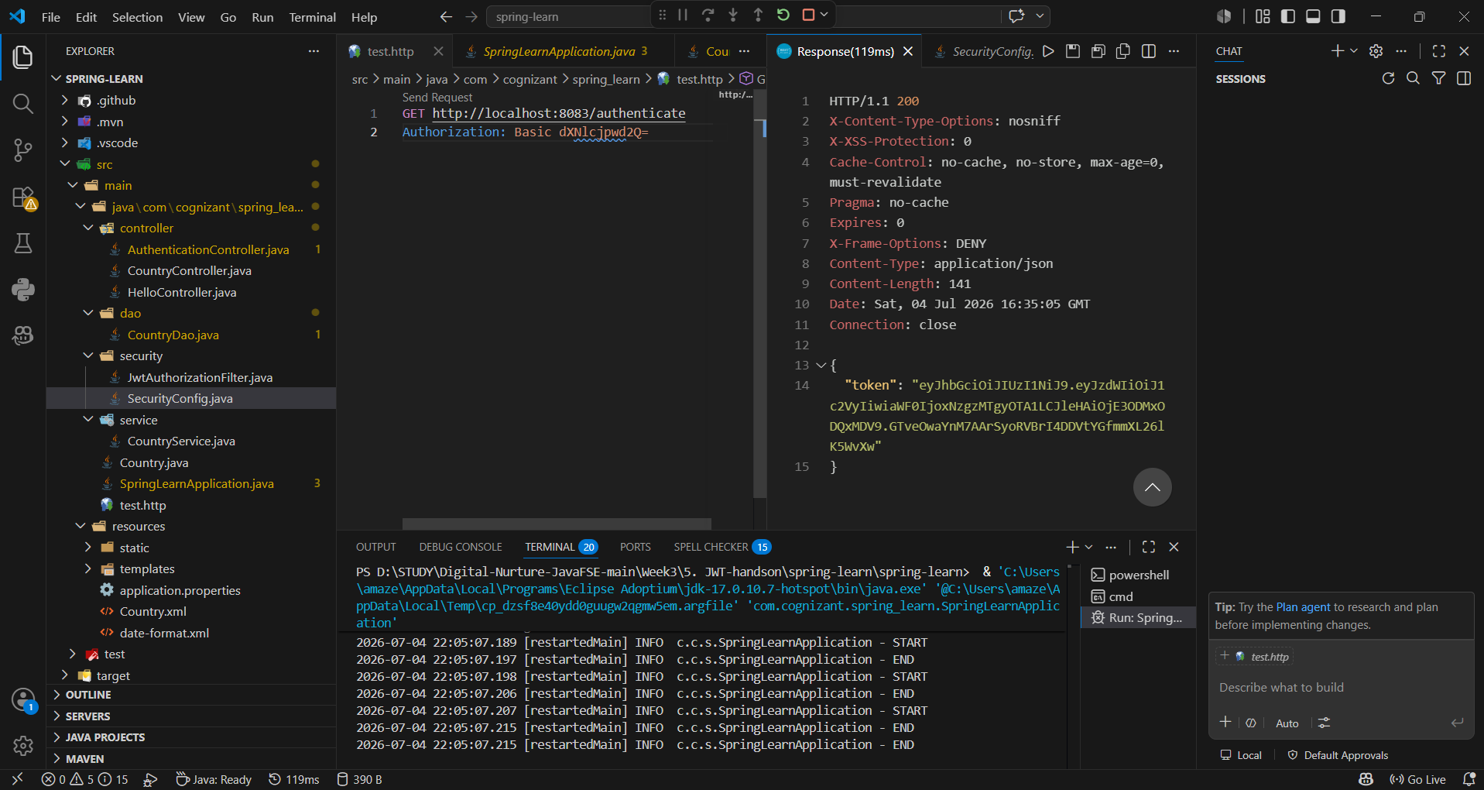
Access Countries with JWT
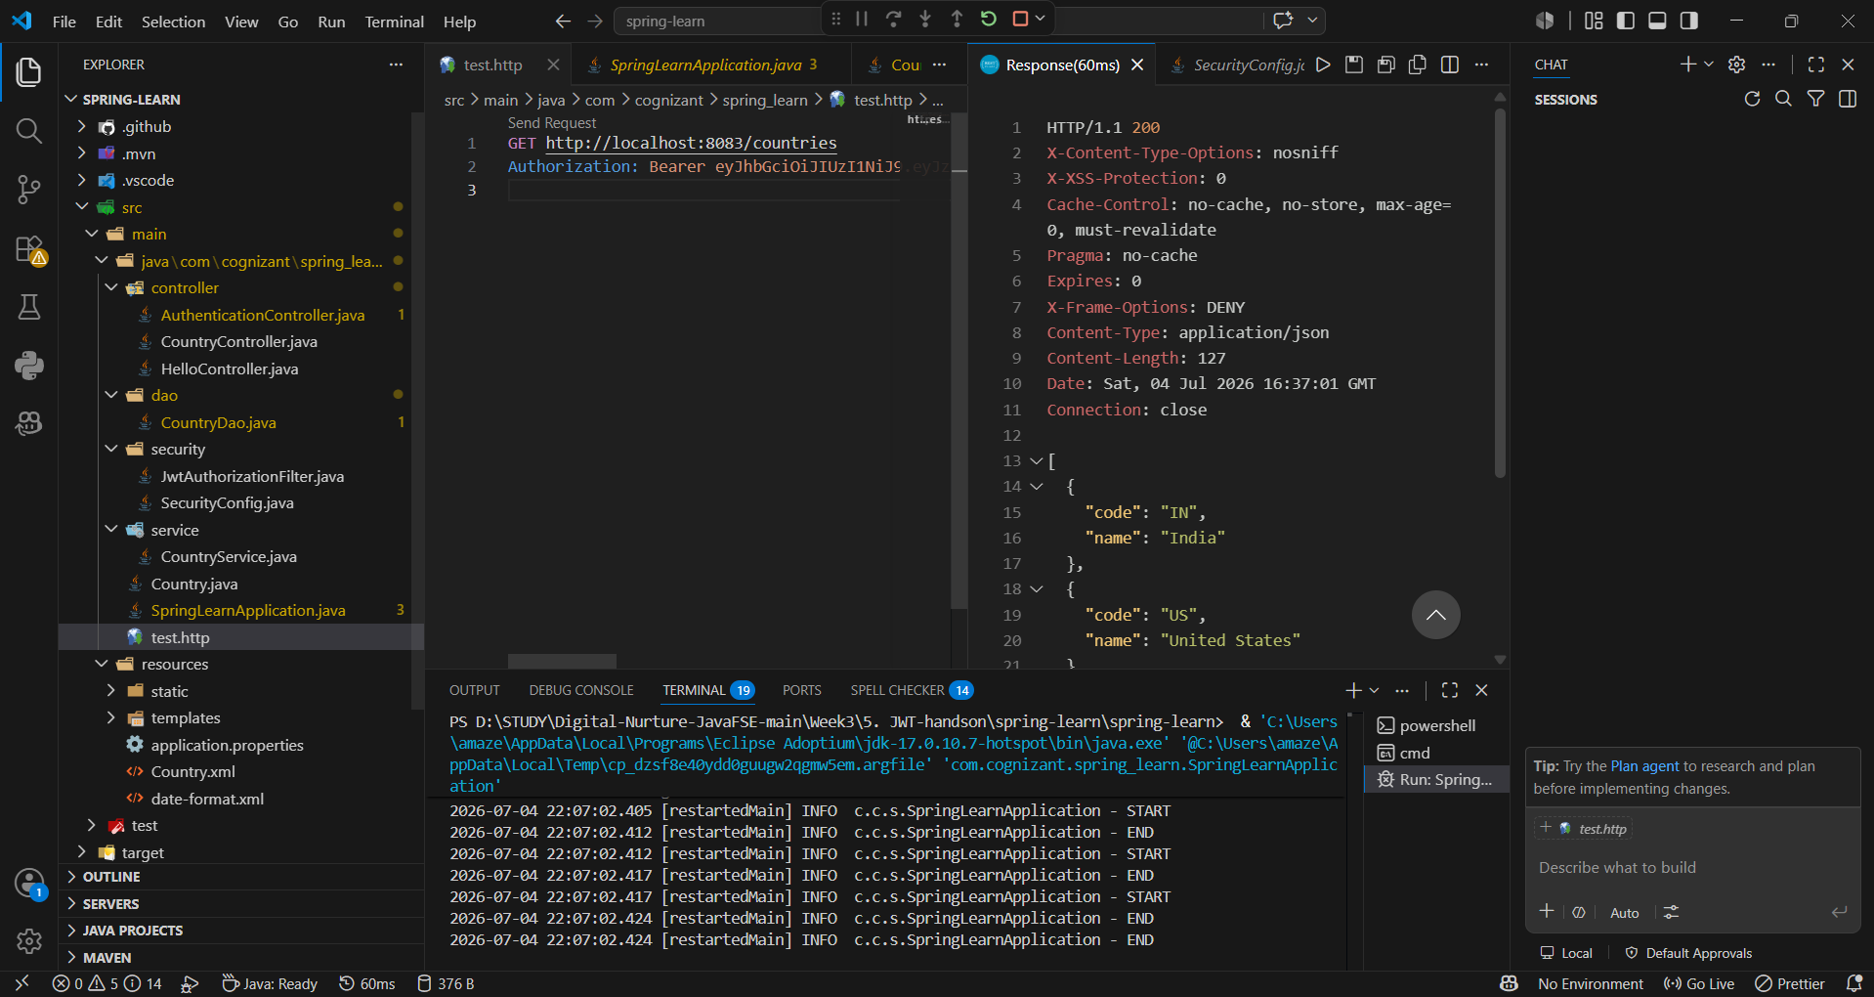

Modified the token
